# **Welcome to Modern Web Development Class!**

**You can reach this document at:**

[**http://moxie.pro/2019july22webssa**](http://moxie.pro/2019july22webssa)

Get ready to code!

You will be using modern tools and techniques to create applications.

You can optionally commit code to GitHub if you have / create an account

# Connecting to Remote Machine

* [HTML 5 Remote Lab Connection PDF](http://www.protechtraining.com/downloads/HTML_5_Remote_Lab_Connection.pdf) (Use for class)
* List of machine assignments: [link](https://docs.google.com/spreadsheets/d/1aUvUVrrxumwqehP0kOkoTyJrcj62tB5By8_VQXyeyoI/edit#gid=0) (choose a machine by adding your name)
* To bring up your Virtual Machine:
* Visit <http://labs.protechtraining.com>
* Supply your username & password

Early to class?

Take this quiz on HTML [link](https://www.w3schools.com/html/html_quiz.asp)

Take this quiz on CSS [link](https://www.w3schools.com/css/css_quiz.asp)

Take this quiz on JS [link](https://www.w3schools.com/js/js_quiz.asp)

System source checklist:

* Set resolution on monitors to RECOMMENDED
* Shortcut through back of building
* Windows
  + command to get list of files? dir
  + shortcuts how to copy, paste, select all?
    - undo - ctrl+Z
    - copy - ctrl + C
    - paste ctrl + V
    - redo - ctrl + Y (undo your ctrl+Z)
    - save - CTRL + s

# Repository:

<https://github.com/JudyLipinski/modernweb>

# OPTIONAL use of GitHub:

Visit [https://GitHub.com/](https://github.com/) and sign into an existing account of yours or sign up for a new account.

If signing up for a new account, you will need to provide an email that you can check and verify, on your phone or by website. If you cannot, the instructor will provide you an email to you. [yournamehere@karmoxie.com](mailto:xxx@karmoxie.com)

Electronic Slides:

[Ch00: Introduction](https://docs.google.com/presentation/d/e/2PACX-1vQWe9MNERFVt3_krGI8vxVv0amv12TgBd5xjMvf8SABFnxkr_LzmnkkS1CIswVrEg1yKsUoCYgZVDxV/pub?start=false&loop=false&delayms=3000)

[Ch01: Overview of Modern Web Dev and Node](https://docs.google.com/presentation/d/e/2PACX-1vRPke0rCUNHIq0GaPTN1xG3-EhU8gAsWWIet6KEbBVuccFfunTzUEMcO4Cx3kOPo6sjCCtKiy9xL1LQ/pub?start=false&loop=false&delayms=3000)

[Ch02: Working with Browsers](https://docs.google.com/presentation/d/e/2PACX-1vRdu45VlJhS6GLESWoOc1PXFM_fqFNti-jmRiDpqCVbiKou4oyZixswI-aqd69DvXL1xQdL0wfE-uyj/pub?start=false&loop=false&delayms=3000)

[Ch03: HTML5 Elements](https://docs.google.com/presentation/d/e/2PACX-1vQe22yVb2bcAP8Zw5GAh81lPWyQgRX-Xe4NLli4Fyj5tQo0ijdSY3cRMWZR4X4e5W-83DQ0cz_e008M/pub?start=false&loop=false&delayms=3000)

[Ch04: CSS3 Features](https://docs.google.com/presentation/d/e/2PACX-1vS8rvC8AxyDfaYZba2irZMYvjmLSOCKQdo8wUk-GY9FE5aASGK-RI5Uj9Mv9V6SVYUY-1I_cTugn9Yn/pub?start=false&loop=false&delayms=3000)

[Ch05: Responsive Web Design](https://docs.google.com/presentation/d/e/2PACX-1vT28JCCkIkiwD26zEtDzi0cQCTPc48z1OlQwnM5-alUsw5g2w4VhuPsKWNefMkIQCOZhQ8HxRV6w0IW/pub?start=false&loop=false&delayms=3000)

[Ch06: ModernJavaScript](https://docs.google.com/presentation/d/e/2PACX-1vRMgbH9_cPpy-zxkZ9GQf5Y91behRUZ8qDZ7K4WJ1_cAWUfZsLt4SSqrGDDvIirfJOy8EBJNOK2OR-p/pub?start=false&loop=false&delayms=3000)

[Ch07: Client-Side Web APIs](https://docs.google.com/presentation/d/e/2PACX-1vSfhmBqqxOYIPk2msksF8FlZ2LiA-AMfUcrJl3MK2VEDvWzHvjg1p4b9VznfW3EkJJ1hlyBGrQZEUC2/pub?start=false&loop=false&delayms=3000)

[Ch08: Working with HTML5Forms](https://docs.google.com/presentation/d/e/2PACX-1vSRWjCT9fH_60QAGzatXxUbcFTR5s-PjUY8nGNuhvkXlqDGO6lpqMC2rdWfkDiybvcnmdNgjNZYkPZG/pub?start=false&loop=false&delayms=3000)

[Ch09: JavaScript Modules](https://docs.google.com/presentation/d/e/2PACX-1vTo6-789ffMv0m1A8AKD00Wc67eQkwxzSKmCv_S43bqozdoK39vkaWSCG69jZ90il-gsnKsDdeeYXQT/pub?start=false&loop=false&delayms=3000)

[Ch10: Unit Testing JavaScript - Jasmine-Karma](https://docs.google.com/presentation/d/e/2PACX-1vTTfb9_0R6FpUohEpcFqruSmUK6hN-BXH1epadx9uHeUjIMfzw56AebH944xyU4KTJyXq1Lg8p7E5M-/pub?start=false&loop=false&delayms=3000)

[Ch11: Summary](https://docs.google.com/presentation/d/e/2PACX-1vTZPYppI8T6thDvJE_HZC6ZowWvP8QTHumEOKuFwRuUytNTO3HzS8-vf6h5KOXFreCLuFngnp04ACjA/pub?start=false&loop=false&delayms=3000)

From c:\ can use

git clone <https://github.com/JudyLipinski/modernweb>

# Parking Lot:

* items we will try to address beyond scope of the course
* server side to force client to download new version of cached css file
* force expiration of html page
* How to hide JS and HTML on client side
* server side detect if user x’s out of browser

# Tech Resources:

* [**https://en.wikipedia.org/wiki/Emmet_(software)**](https://en.wikipedia.org/wiki/Emmet_(software))
* **MDN docs** [**https://developer.mozilla.org/en-US/docs/Web/JavaScript**](https://developer.mozilla.org/en-US/docs/Web/JavaScript)
* **Latest version of HTML**
  + [**https://html.spec.whatwg.org/multipage/**](https://html.spec.whatwg.org/multipage/)
* Microsoft Edge to use Chromium [**https://www.businessinsider.com/microsoft-edge-google-chromium-browser-2018-12**](https://www.businessinsider.com/microsoft-edge-google-chromium-browser-2018-12)
* [**https://www.google.com/amp/s/blog.sonatype.com/using-nexus-3-as-your-repository-part-2-npm-packages%3fhs_amp=true**](https://www.google.com/amp/s/blog.sonatype.com/using-nexus-3-as-your-repository-part-2-npm-packages%3fhs_amp=true)
* **LiveShare on VSCode** [**https://marketplace.visualstudio.com/items?itemName=MS-vsliveshare.vsliveshare**](https://marketplace.visualstudio.com/items?itemName=MS-vsliveshare.vsliveshare)
* **JSON SCHEMA** [**https://json-schema.org/learn/getting-started-step-by-step.html**](https://json-schema.org/learn/getting-started-step-by-step.html)
* **released 4 month ago** [**https://www.npmjs.com/package/modernizr**](https://www.npmjs.com/package/modernizr)
* + [**https://tabnine.com/blog/deep**](https://tabnine.com/blog/deep)

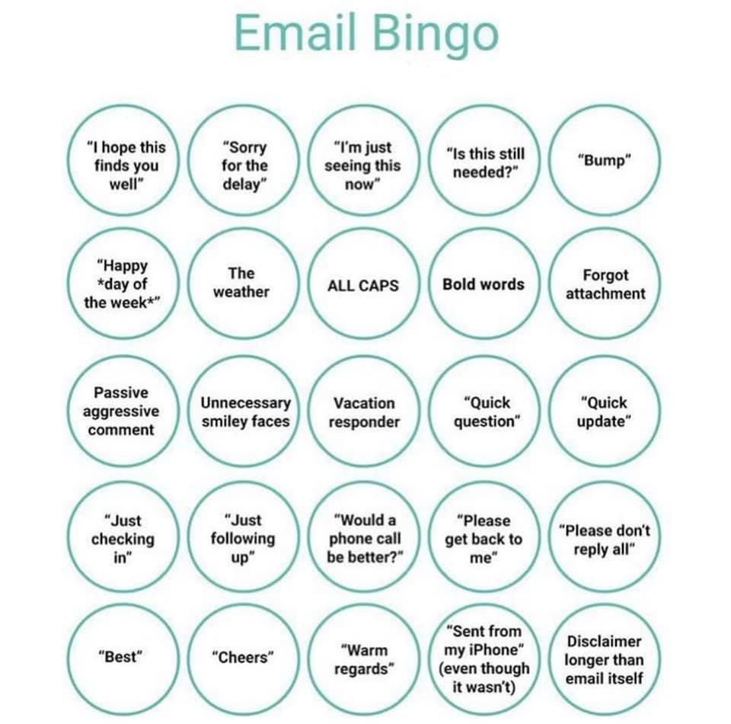

Tuesday Review:

* What’s something new or interesting you learned from the previous day?
* Any questions?
* Emmet Abreviations
  + ol>li.steps*10
* HTML5 semantic tags
  + article, main, footer, nav, header, aside,
* htmltagwrap
* VS Code extensions
  + At SSA search extensions is blocked, instead use VSIX to install
* <pre>

Wednesday Review:

* What’s something new or interesting you learned from the previous day?
* Any questions?
* bootstrap
  + SASS
  + C
* @media print { }
* @media screen
* attribute value selectors
  + <a title=”example”>
  + []
  + a[title*=am]
  + a
* responsive web design RWD
  + responsive images with bootstrap
* modernizr

Thursday Review:

* array prototype functions
  + map() filter() foreach()
* arrow function
  + =>
* js types
  + number
  + null
  + string
  + undefined
  + boolean
* for of or for in loops
  + for(const item in list) {